For Classification we have fixed set of outputs or class labels.

For Regression we have any real value or infinite set of continuous value as output.

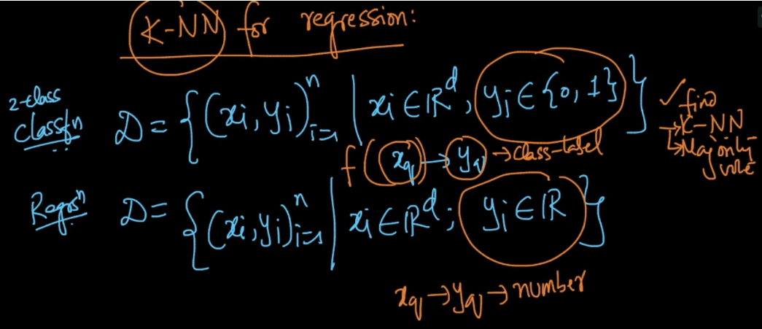

So how do we find output for given query point xq.

* We’ll apply the same step to find k nearest points
* Then we’ll take either mean or median of all the nearest points as output.

Median will be less prone to outliers.

